Image Processing **Using FPGA**

Mars IITR

## Introduction:

The project was initiated on 01/06/2022 as a training project, accompanied by Abhikanchit, Jayant, Mayank, Rajeev and monitored by Apurba prasad Padhy and Chirag Arora, project expects basic knowledge of Verilog programming and FPGA implementations.

## Problem statement:

1.) Design a prototype of a chip by which a specific task is applied on a grayscale image, given by the user.

**State of ‘select’ signal Operation**

2’b00 Increase brightness by ‘value’

2’b01 Decrease brightness by ‘value’

2’b10 Binarize the image using ‘threshold’

2’b11 Invert the image

2.) Apply filter to image asked by the user.

1. Motion blur
2. Sharpen image
3. Edge detection
4. Noise reduction

## Task divisions:

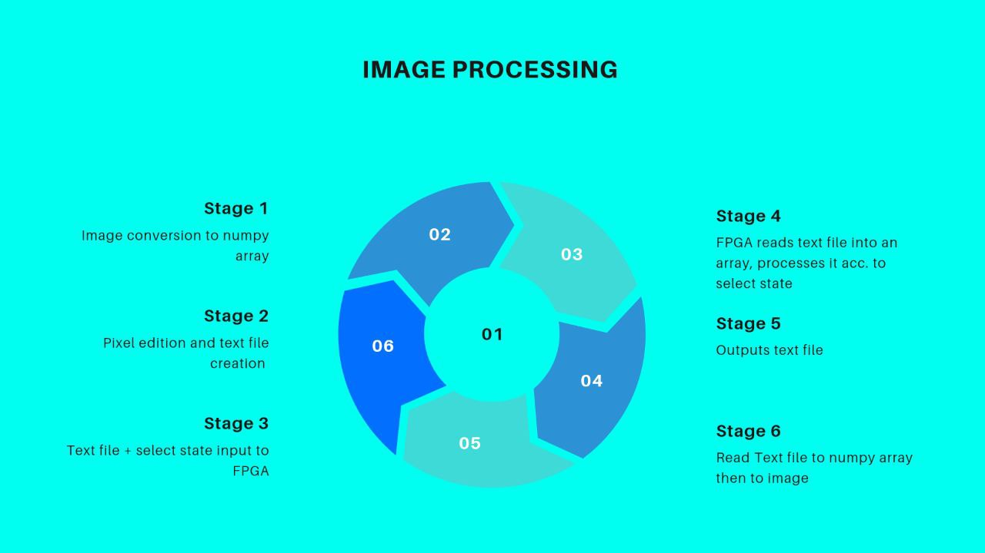

1. All 1.team members were required to learn Verilog basics and complete problem statement
2. Python: Image to bin text file, output text file to image, kernel generation and NumPy handling with python – done by Rajeev.
3. Image filters:

|  |
| --- |
| Motion blur |
| Sharpen image |
| Edge detection |
| Noise reduction |

1. Git repository:
   1. Readme.md: Abhikanchit
   2. Poster: Mayank
   3. repository push: Jayant
   4. Report: Rajeev

## Implementations and Future vision:

FPGA chip has been a revolution in telecoms, automotives, remotely controlled devices and other programmable electronic devices, where good functioning and flexibility is expected.

We tried to implement it as a image processor so that it can be used in Robots, drones, rovers etc for to support improved quality of processing.

### FPGA advantages:

* Excellent performance with reduced latency advantages: FPGAs provide low latency as well as deterministic latency
* Cost effectiveness: FPGAs can be reprogrammed after manufacturing for different data types and capabilities, delivering real value over having to replace the application with new hardware.
* Energy efficiency: Utilizing development tools like INT8 quantization is a successful method for optimizing machine learning frameworks like TensorFlow and PyTorch. Proper utilization of INT8 can reduce both memory and computing requirements, which can shrink memory and bandwidth usage by as much as 75%.

### Disadvantages of FPGA:

* + Complexity
  + More expensive than custom silicon chip

## conclusion:

Even having HDL complexity and high manufacturing cost, FPGA chip is used revolutionary since ‘90s, because of its flexibility, speed and efficiency. Overall, it is a good approach to use FPGA chip in robots to get increased performance.